Micah Craypo
PTA 1010
Autism:
Pathology & Physical Therapy
Autistic disorder (or autism): Is a childhood disorder characterized by significant impairment in social interactions and communication and by restricted patterns of behavior, interest, and activities.
Origins of Autism
- 1930s & 1940s- Specific D/O with Limited Range and Type of Emotions
- Environmental- Parents not Providing Sufficient Support
- 1950s & 1960s- Psychologist Harry Harlow & Baby monkeys
- DSM-IV-TR/ PDD- Must meet 6 out of 12.

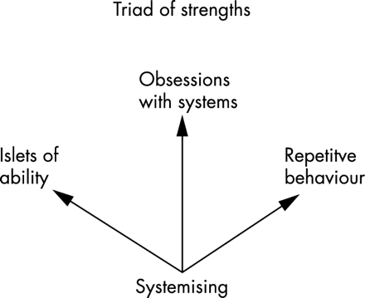
Autism: is a complex neurobiological disorder that interferes with normal development in language, social interaction and behavior. The technical term, autism spectrum disorders (ASDs), refers to a group of developmental disorders that are usually first diagnosed in early childhood and include: autistic disorder, pervasive developmental disorder not otherwise specified (PDD-NOS) and Asperger’s syndrome. It also includes two rare disorders, Rett disorder and childhood disintegrative disorder (SARRC).

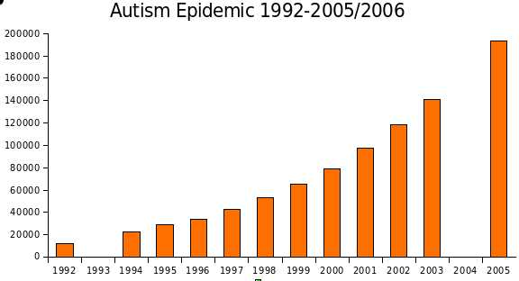

Physical Therapy: Pediatrics
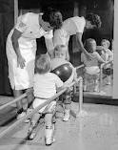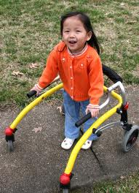

Screening: Distinguish comparative behaviors.
- Screener
- Denver II Development
- Neurodevelopmental
- Bayley Infant
Assessment: Determining therapeutic service needs.
- Pediatric Evaluation of Disability
- Motor Proficiency
- Bayley Scales of Infant & Toddler
- Development III

Physical Therapy in Treating Autism
- Motor function & developmental delay
- Respiratory control
- Balance & coordination deficits
- Misalignments in musculoskeletal system
- Developing fitness programs
Research
Autism. Opposing Viewpoints Online Collection. Gale, Cengage Learning, 2010. Web 28 Jan. 2012.
Pagliarulo, Michael. Introduction to Physical Therapy 4th edition. St. Louis, MO ed. Kathryn Falk.
Durand, Mark & Barlow, David. Essentials of Abnormal Psychology 5th edition. 2010, 2006 Wadsworth, Cengage Learning. Ed. Jaime Perkins.
DSM-IV-TR. Diagnostic Critieria, American Psychiatric Association. American Psychiatric Publishing, Inc. Arlington, VA.

